**Developer’s Guide:**

**Software**: Visual Studio 2022.

* Download source code via link: [*https://github.com/KhaiCuong/KarnelTravelAPI.git*](https://github.com/KhaiCuong/KarnelTravelAPI.git)

[*https://github.com/KhaiCuong/KarnelTravelView.git*](https://github.com/KhaiCuong/KarnelTravelView.git)

**Database**:

* Microsoft SQL Server Management Studio 18 (SQL Server 2019).
* Run a database: open file KarnelTravelDB.sql and Execute it to get a database first
* **I. Connect SQL Server:**

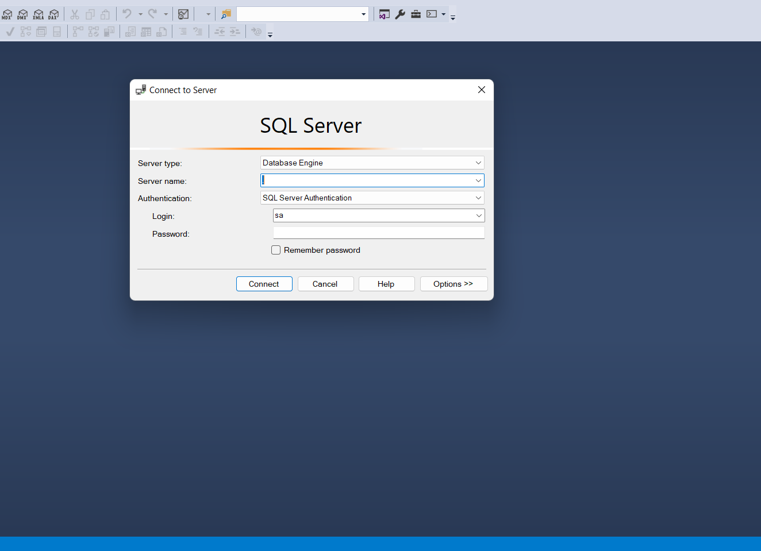  
Step1: -login with your account

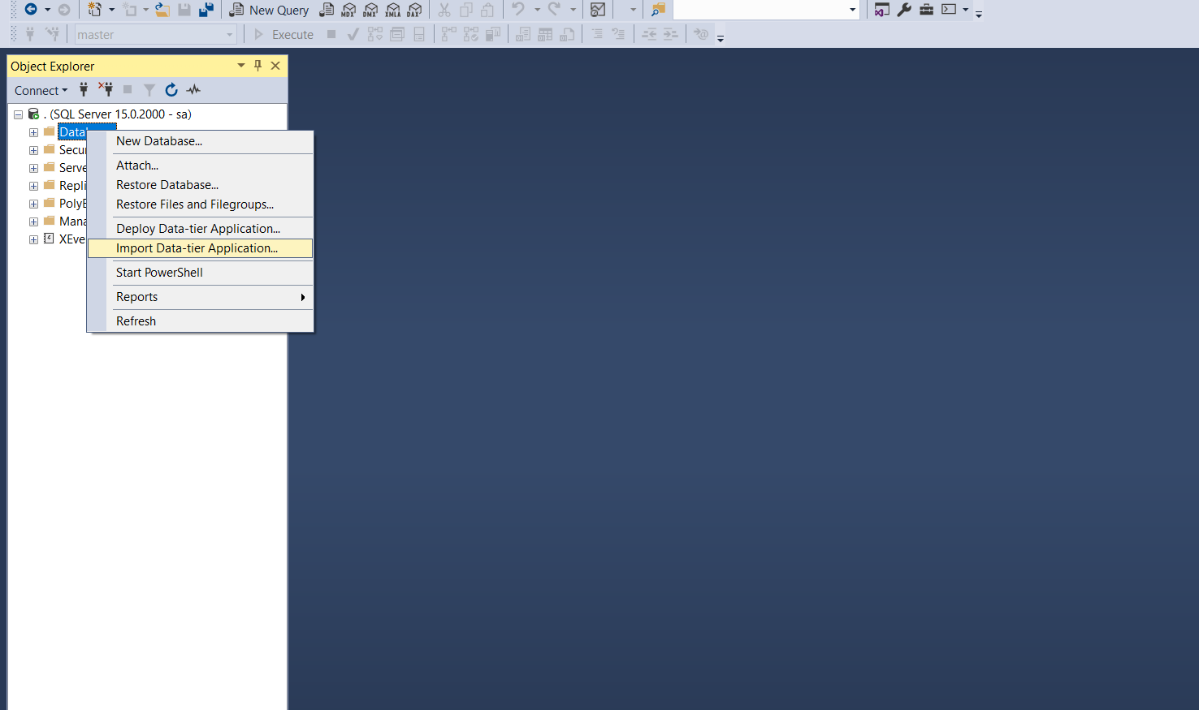 Step 2: -right click on database and choose “Import Data-tier Application”

Step3: Choose Browse-> choose KarmelTravelDB.bacpac in the folder named “Database”

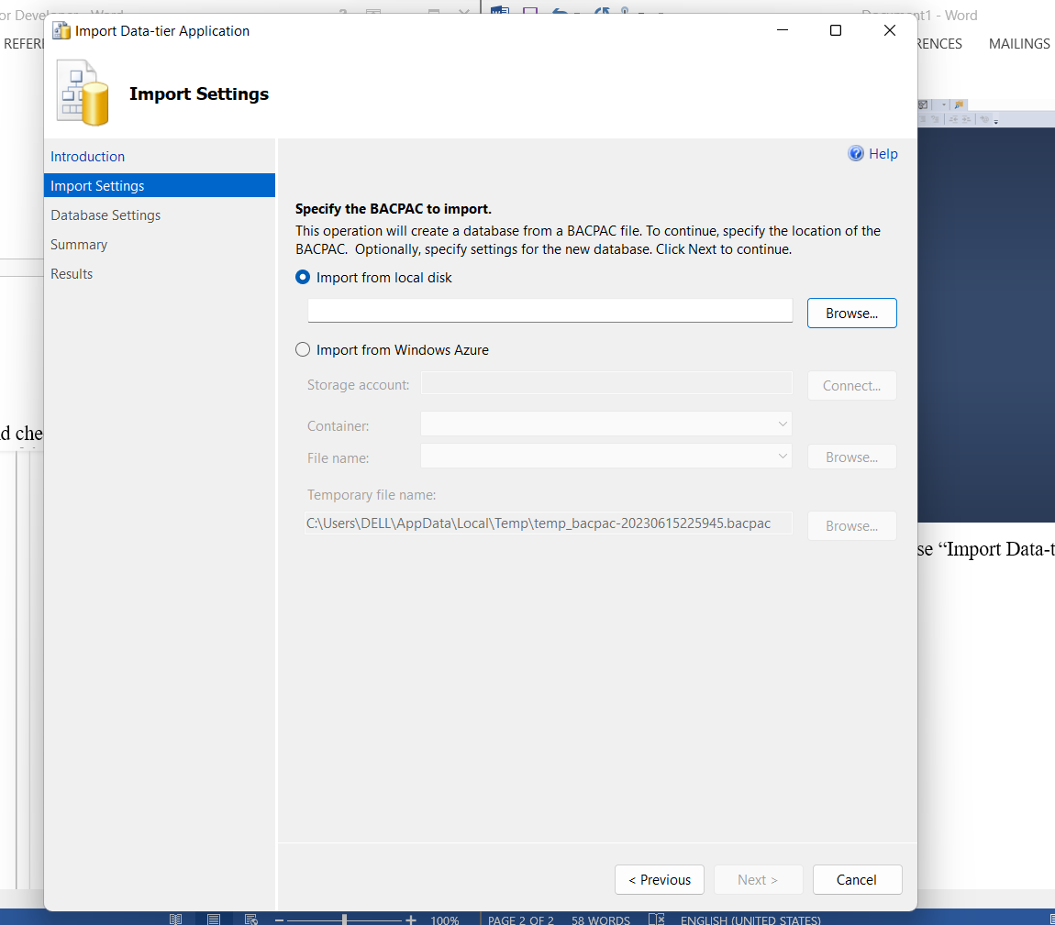

Step 4: Choose “Close” to finish

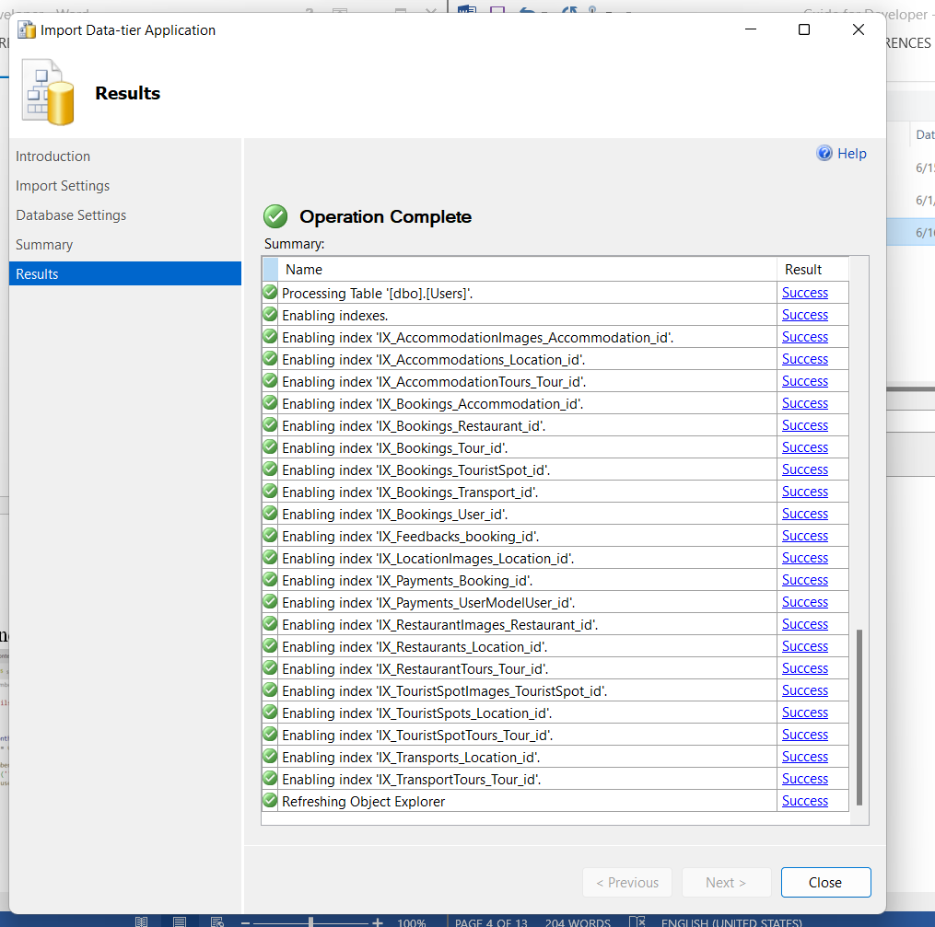

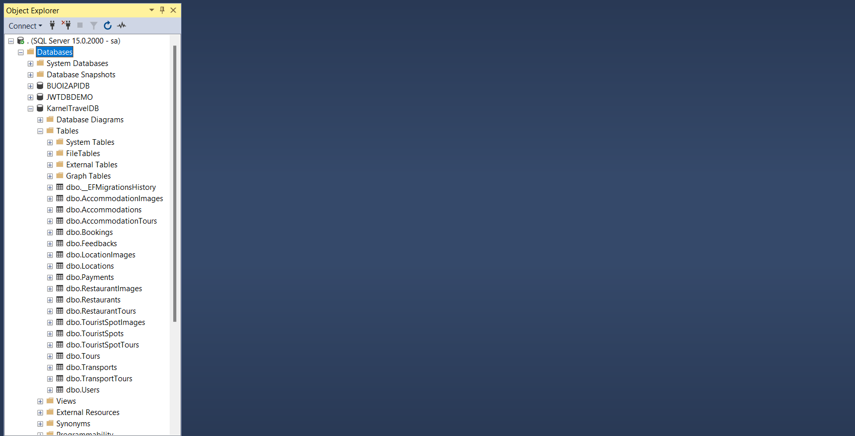Finaly you have database

II.Run Back-end

Step 1: Choose Source -> BE and double click to BE folder

Step 2 : Right click choose Open with -> Microsoft Visual Studio 2022

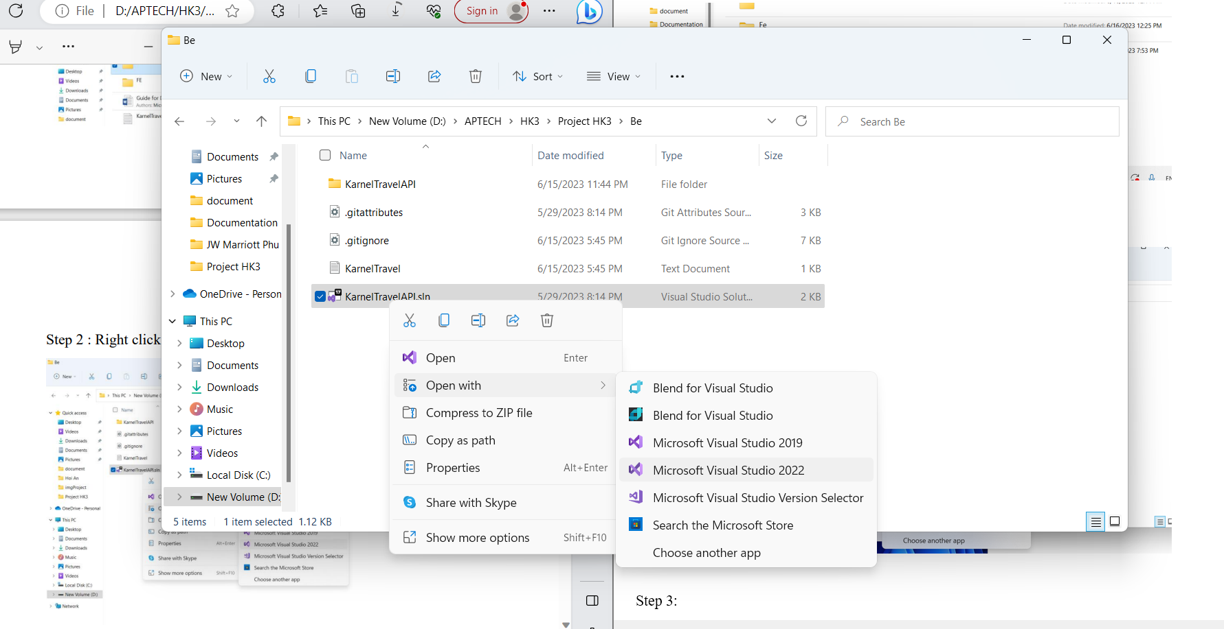

Step 3: Change (server, database, user id, password,...) according to your sql server

See sample photos below

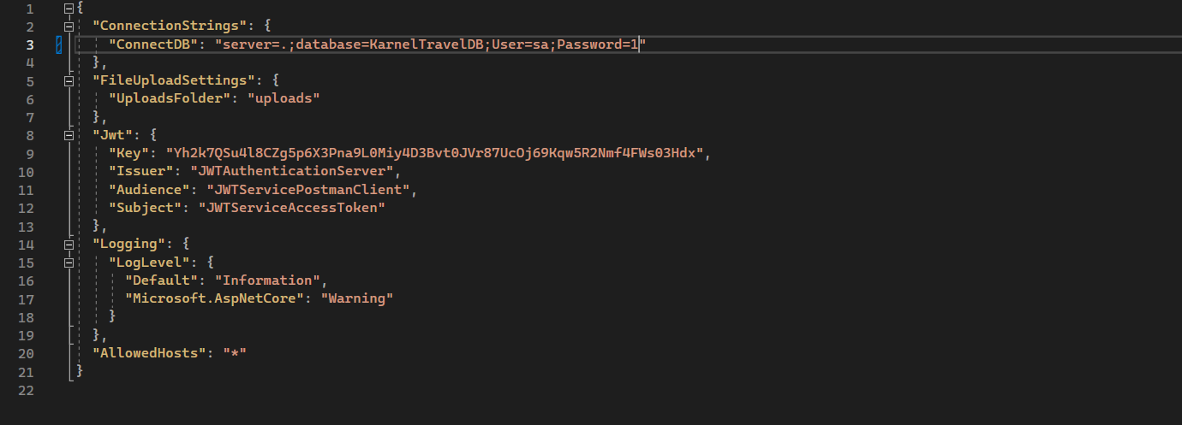

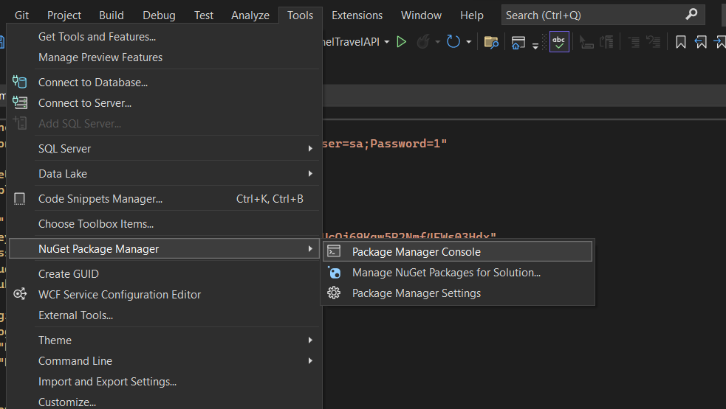Step 4 :Click Tools-> NuGet Package Manager -> choose Package Manager Console

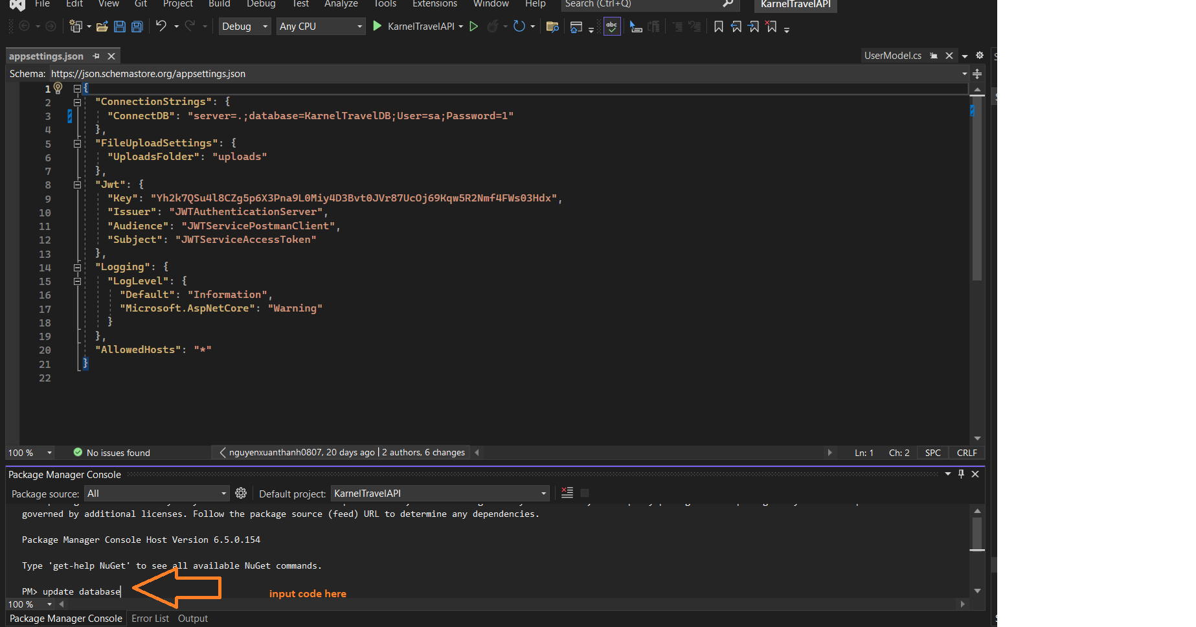Step5: input code update database

***After all***

* Change your ConnectionStrings in appsetting.json at Folder:
* 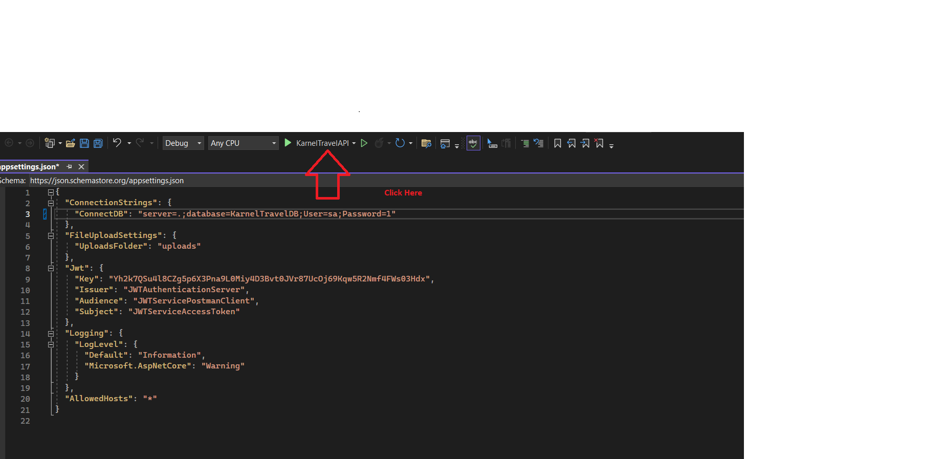Hit run button have green color

Check the package version if it’s necessary

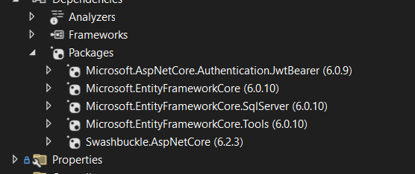

Step 6: After that the program will open a tab as follows

III. Run FontEnd

Step 1: Open Visual Studio Code and choose Open Folder

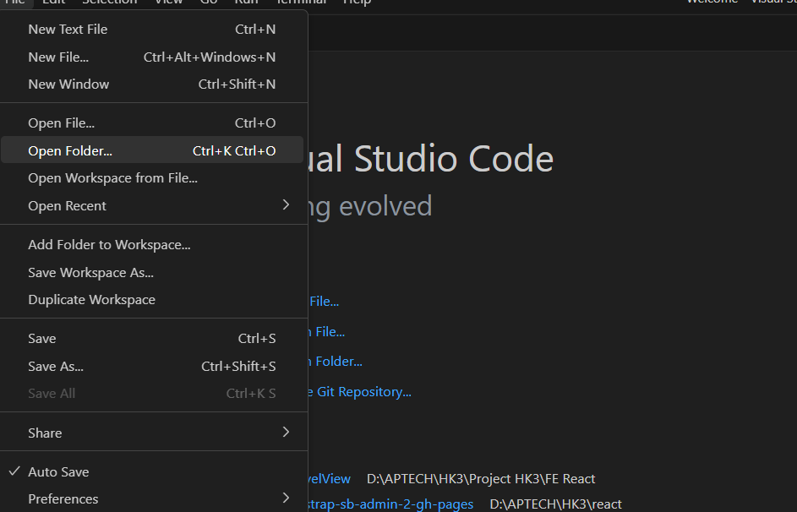

Step 2: Open Folder FE -> open Folder KarnelTravelView

Step 3: click to the URL bar

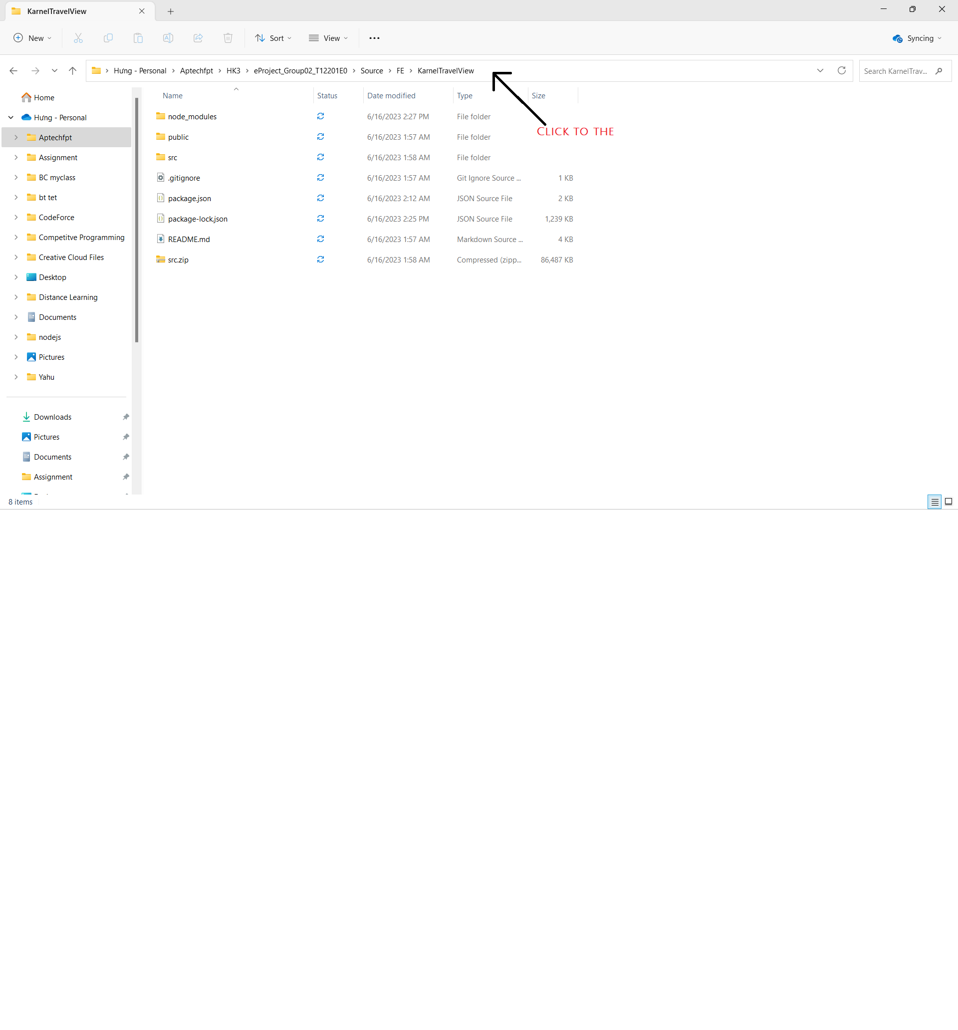

Step 4: Type “cmd” on the URL bar as follows

Step 5: after that the command prompt will open.

Step 6: Type “code .” as follows to open the project in the visual studio code

Step 7: click new Terminal

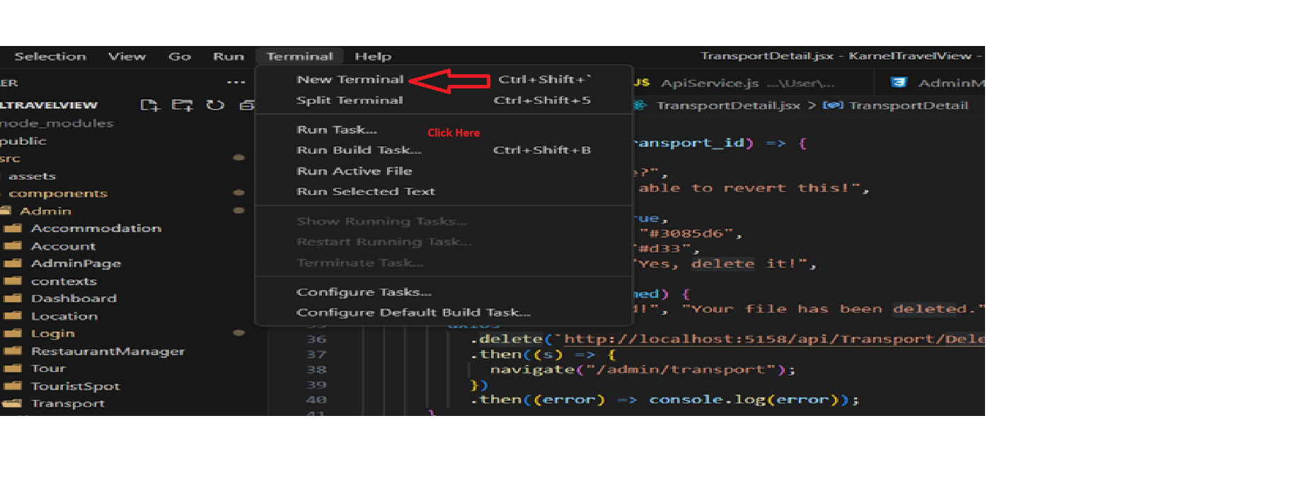

Step 8: Run code: “npm install”, and wait till finished

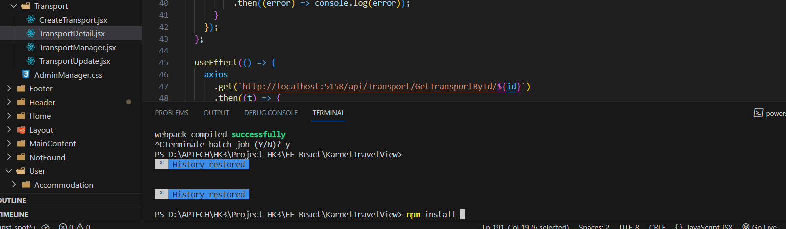

Step 9: Run code: “npm Start”, and wait till finished

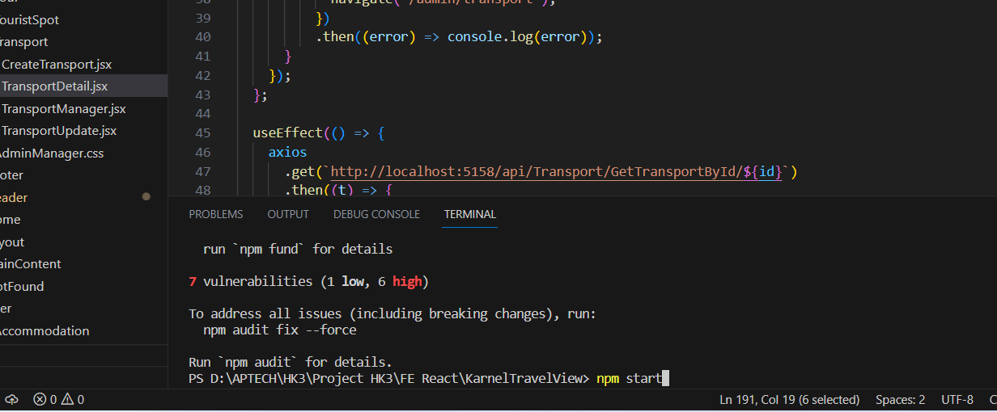

* If it doesn’t work. Try: npm install react-scripts –save

* After that run npm start to start the server

Step 10: finally: Enjoy Travel

